EcrNow Operations Guide: Log Files, Directory Access, and Database Tables Documentation

## **Note:**

## **Directory paths mentioned in this document might change based on environment configurations or Docker volumes. Please ensure you verify the paths in your specific setup.**

## Log File

**Path:** /c/ecr-now/ecrNow.log (Unix) or C:\ecr-now\ecrNow.log (Windows)

### **macOS and Linux**

1. Open Terminal.
2. Run the following command to check the log file:

|  |
| --- |
| tail -f /c/ecr-now/ecrNow.log |

### **Windows**

1. Open PowerShell.
2. Run the following command to check the log file:

|  |
| --- |
| Get-Content C:\ecr-now\ecrNow.log -Wait |

#### **Accessing Log File Using Text Editor:**

**macOS:**

**Navigate to Path:**

* Open Finder.
* Go to Go -> Go to Folder... or press Cmd + Shift + G.
* Enter /c/ecr-now/ and click Go.

**Open File with Text Editor (e.g., Mack):**

Double-click on ecrNow.log to open it with the default text editor (like TextEdit).

Alternatively, right-click on ecrNow.log, choose Open With, and select Mack or another text editor.

**Linux:**

**Navigate to Path:**

* Open your file manager (e.g., Nautilus for GNOME, Dolphin for KDE).
* Enter /c/ecr-now/ or the desired directory path in the address bar.

**Open File with Text Editor (e.g., VS Code):**

* Double-click on ecrNow.log to open it with the default text editor associated with your desktop environment.
* To use a specific text editor:
* Right-click on ecrNow.log.
* Choose Open With and select VS Code or another text editor from the list.

**Windows:**

**Navigate to Path:**

* Open File Explorer.
* Go to C:\ecr-now\ or the desired directory path.

**Open File with Text Editor (e.g., Notepad++):**

* Double-click on ecrNow.log to open it with the default text editor associated with Windows.
* Alternatively, right-click on ecrNow.log, choose Open with, and select Notepad++ or another text editor.

## **BSA Output Directory**

**Path:** /c/ecr-now/bsa-output/ (Unix) or C:\ecr-now\bsa-output\ (Windows)

**Files Stored:**

TriggerQueryBundle .Json- FHIR Bundle

LoadingQueryBundle .json- FHIR Bundle

create_report.xml - Contains CCDA output for the given patient

### **macOS and Linux**

1. Open Terminal.
2. Run the following command to list files in the BSA Output directory:

|  |
| --- |
| ls /c/ecr-now/bsa-output/ |

Example

|  |
| --- |
| Cat /c/ecr-now/bsa-output/create_report.xml |

### **Windows**

1. Open PowerShell.
2. Run the following command to list files in the BSA Output directory:

|  |
| --- |
| dir C:\ecr-now\bsa-output\ |

Example

|  |
| --- |
| Get-Content /c/ecr-now/bsa-output/create_report.xml |

**Accessing Log File Using Text Editor:**  
**macOS:**

**Navigate to Path:**

* Open Finder.
* Go to Go -> Go to Folder... or press Cmd + Shift + G.
* Enter /c/ecr-now/bsa-output/ and click Go.

**View Files with Text Editor (e.g., Mack):**

* Double-click on any file (TriggerQueryBundle, LoadingQueryBundle, create_report.xml) to open it with the default text editor.
* Alternatively, right-click on the file, choose Open With, and select Mack or another text editor.

**Linux:**

**Navigate to Path:**

* Open your file manager (e.g., Nautilus for GNOME, Dolphin for KDE).
* Enter /c/ecr-now/bsa-output/ or the desired directory path in the address bar.

**View Files with Text Editor (e.g., VS Code):**

* Double-click on any file (TriggerQueryBundle, LoadingQueryBundle, create_report.xml) to open it with the default text editor associated with your desktop environment.
* To use a specific text editor:
* Right-click on the file.
* Choose Open With and select VS Code or another text editor from the list.

**Windows:**

**Navigate to Path:**

* Open File Explorer.
* Go to C:\ecr-now\bsa-output\ or the desired directory path.

**View Files with Text Editor (e.g., Notepad++):**

* Double-click on any file (TriggerQueryBundle, LoadingQueryBundle, create_report.xml) to open it with the default text editor associated with Windows.
* Alternatively, right-click on the file, choose Open with, and select Notepad++ or another text editor.

Database Tables Documentation

ecrNow Database Table  
  
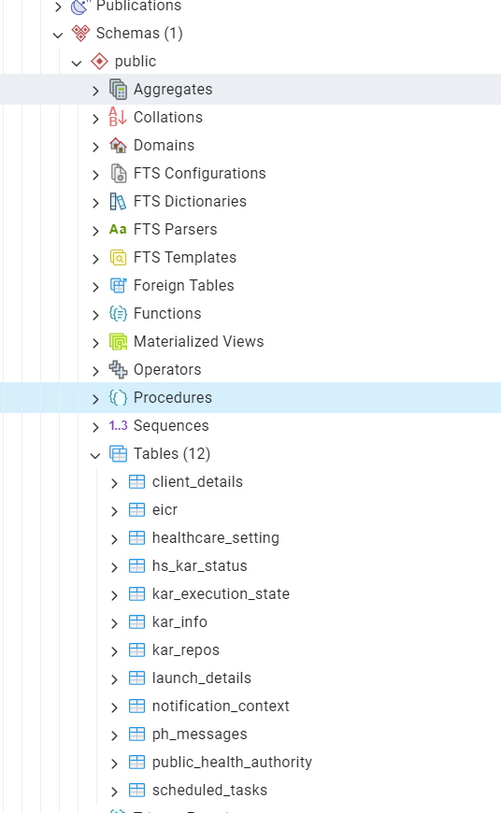

#### Description **client_details**

* **Description:** Stores client details necessary for interacting with external systems.

#### **eicr**

* **Description:** Stores records of each eICR (Electronic Initial Case Report) created.

#### **healthcare_setting**

* **Description:** Represents a practice location such as a doctor's office or hospital. Each setting employs EHRs, typically with a dedicated FHIR Server instance either cloud-hosted or in a data center.

#### **hs_kar_status**

* **Description:** Manages Knowledge Artifact status for each healthcare setting. When isActive is true, associated Knowledge Artifacts are evaluated based on notifications.

#### **kar_execution_state**

* **Description:** Manages execution context data across timers and jobs, optimizing data reuse and reducing recomputation in workflows.

#### **kar_info**

* **Description:** Stores metadata related to Knowledge Artifacts available from a repository for healthcare settings to activate, deactivate, or configure.

#### **kar_repos**

* **Description:** Represents instances of FHIR Servers hosting Knowledge Artifacts.

#### **notification_context**

* **Description:** Stores persistent information received from an EHR for processing notifications and applying Knowledge Artifacts.

#### **ph_messages**

* **Description:** Tracks incoming and outgoing messages to/from the BSA.

#### **public_health_authority**

* **Description:** Represents entities of public health authorities with details for interacting with FHIR servers.

#### **scheduled_tasks**

* **Description:** Entity class managing scheduled tasks in the application, storing scheduling and execution details.